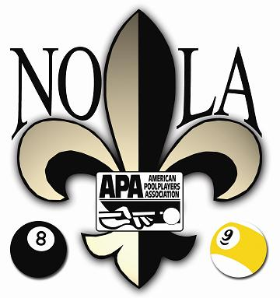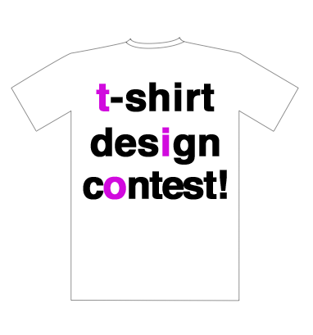
NOLA APA-WPQ TEAM SHIRT CONTEST- JUNE 2023!!!
Open to all teams that are participating in WPQ (LTC)!

Contest Rules: Register by Wednesday, May 31, 2023 by filling out this form and sending into our office in your team envelope. Team T-shirts will be judged by some staff members of the IP Biloxi after the second round begins at our NOLA APA World Pool Qualifier (LTC) on Saturday, June 10, 2023. Winner will be announced shortly thereafter judging is complete. Teams that are participating in the team t-shirt contest, will be able to take team pictures during that time. Pictures professionally taken by Desi Williams!

By submitting this form, you’re agreeing to the following terms and conditions. NOLA APA has the right, in its sole discretion, to determine which submissions are eligible for entry and which entries will be declared the winner. All determinations made by NOLA APA are final. If you’re disqualified from the NOLA APA World Pool Qualifier (LTC), your entry in this contest will be deemed ineligible.

Note: Shirts displaying trademarks (e.g. APA logo, Imperial Palace Biloxi logo, trademarked cartoon characters, etc.), X-rated artwork or violence will be disqualified. APA awarded patches will not disqualify your entry.

2023 TEAM SHIRT CONTEST REGISTRATION FORM

TEAM NAME__________________________________________________________

TEAM CAPTAIN_____________________________Phone #____________________

